**dRiley**

**Fromont**

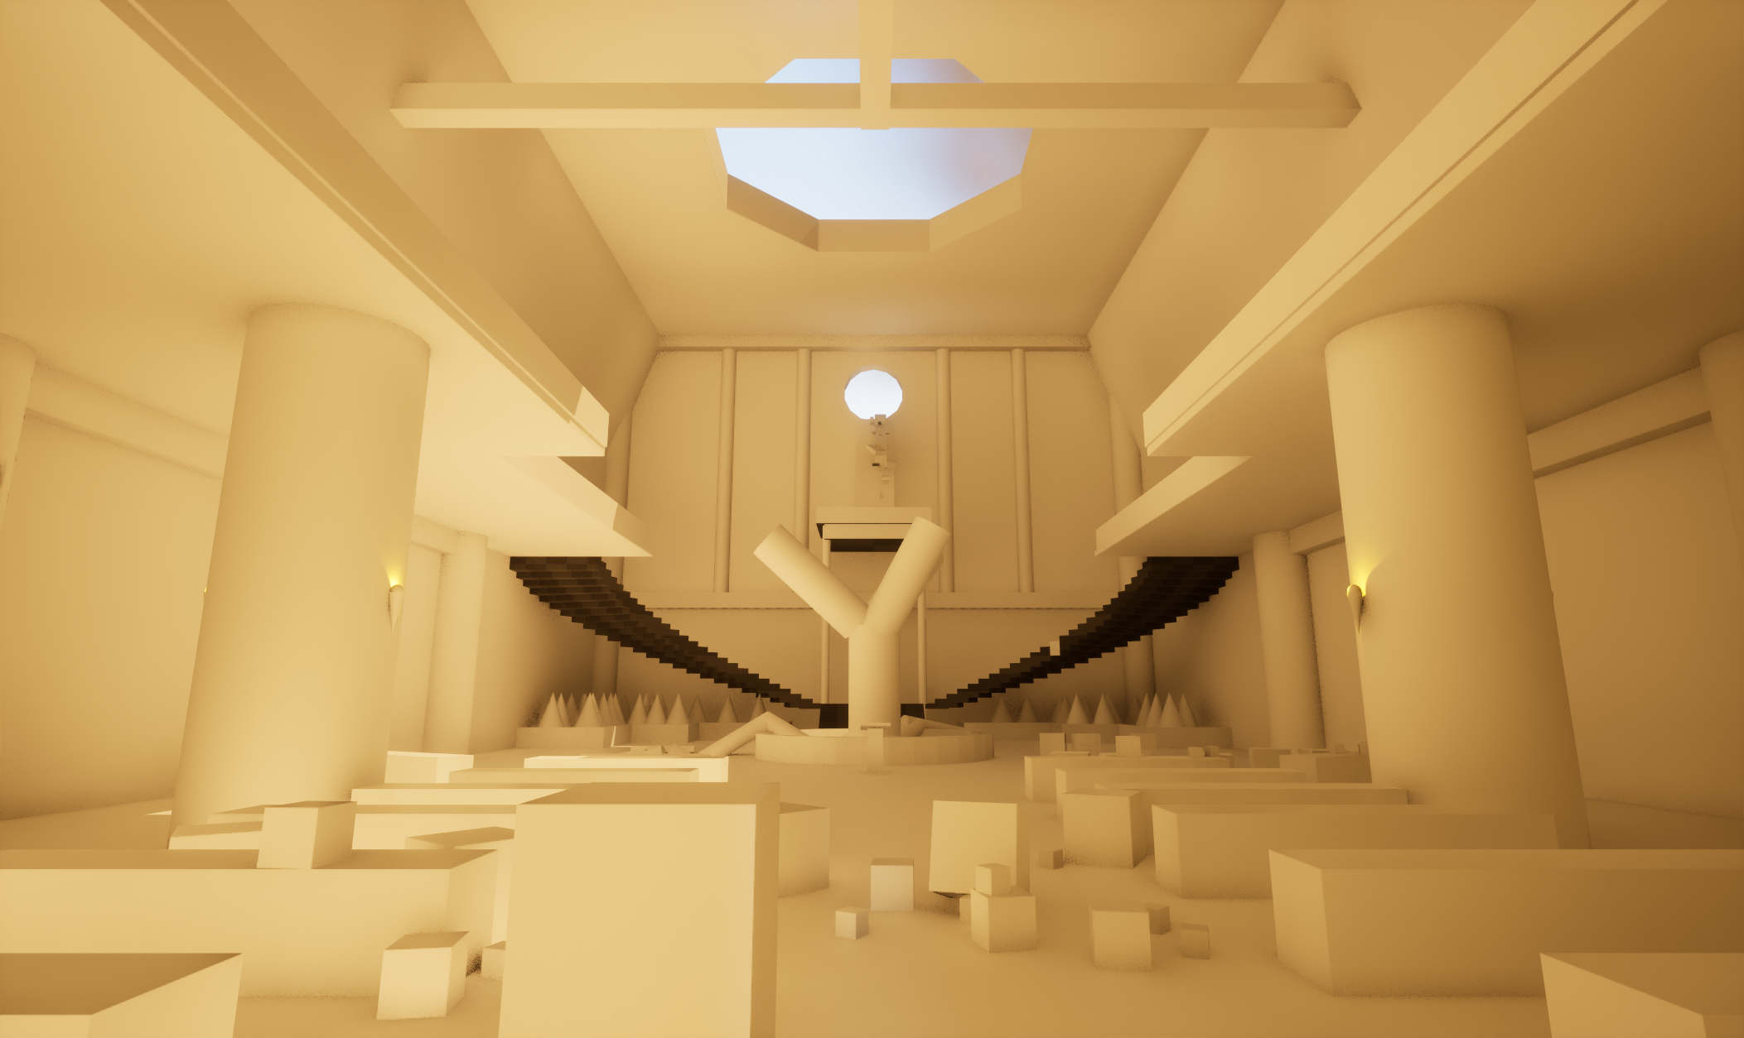**GAT170-Scene Proposal**

**Layout & Grey-boxing**

The scene I am looking to make is an abandoned ruin classroom set in a fantasy world. The scene consists of a large room with two floors that are to contain a number of props as well as a few interactive objects for the player to use. The room and its components are broken down below with supplementary screenshots of the grey box environment.

**Lecture Hall**

 The majority of the scene’s architecture would be made from a number of stone materials, with a majority of furniture being cut from stone or crudely fashioned with wood. The bottom floor consists of a lecture hall with carved stone benches and pillars populating the front of the interior. There will be some loose debris of rock scattered between the rows of benches which the player may pick up and move with physics being applied to them when not being carried. The sconces on the walls can be interacted with to light them or snuff them out (fire VFX)

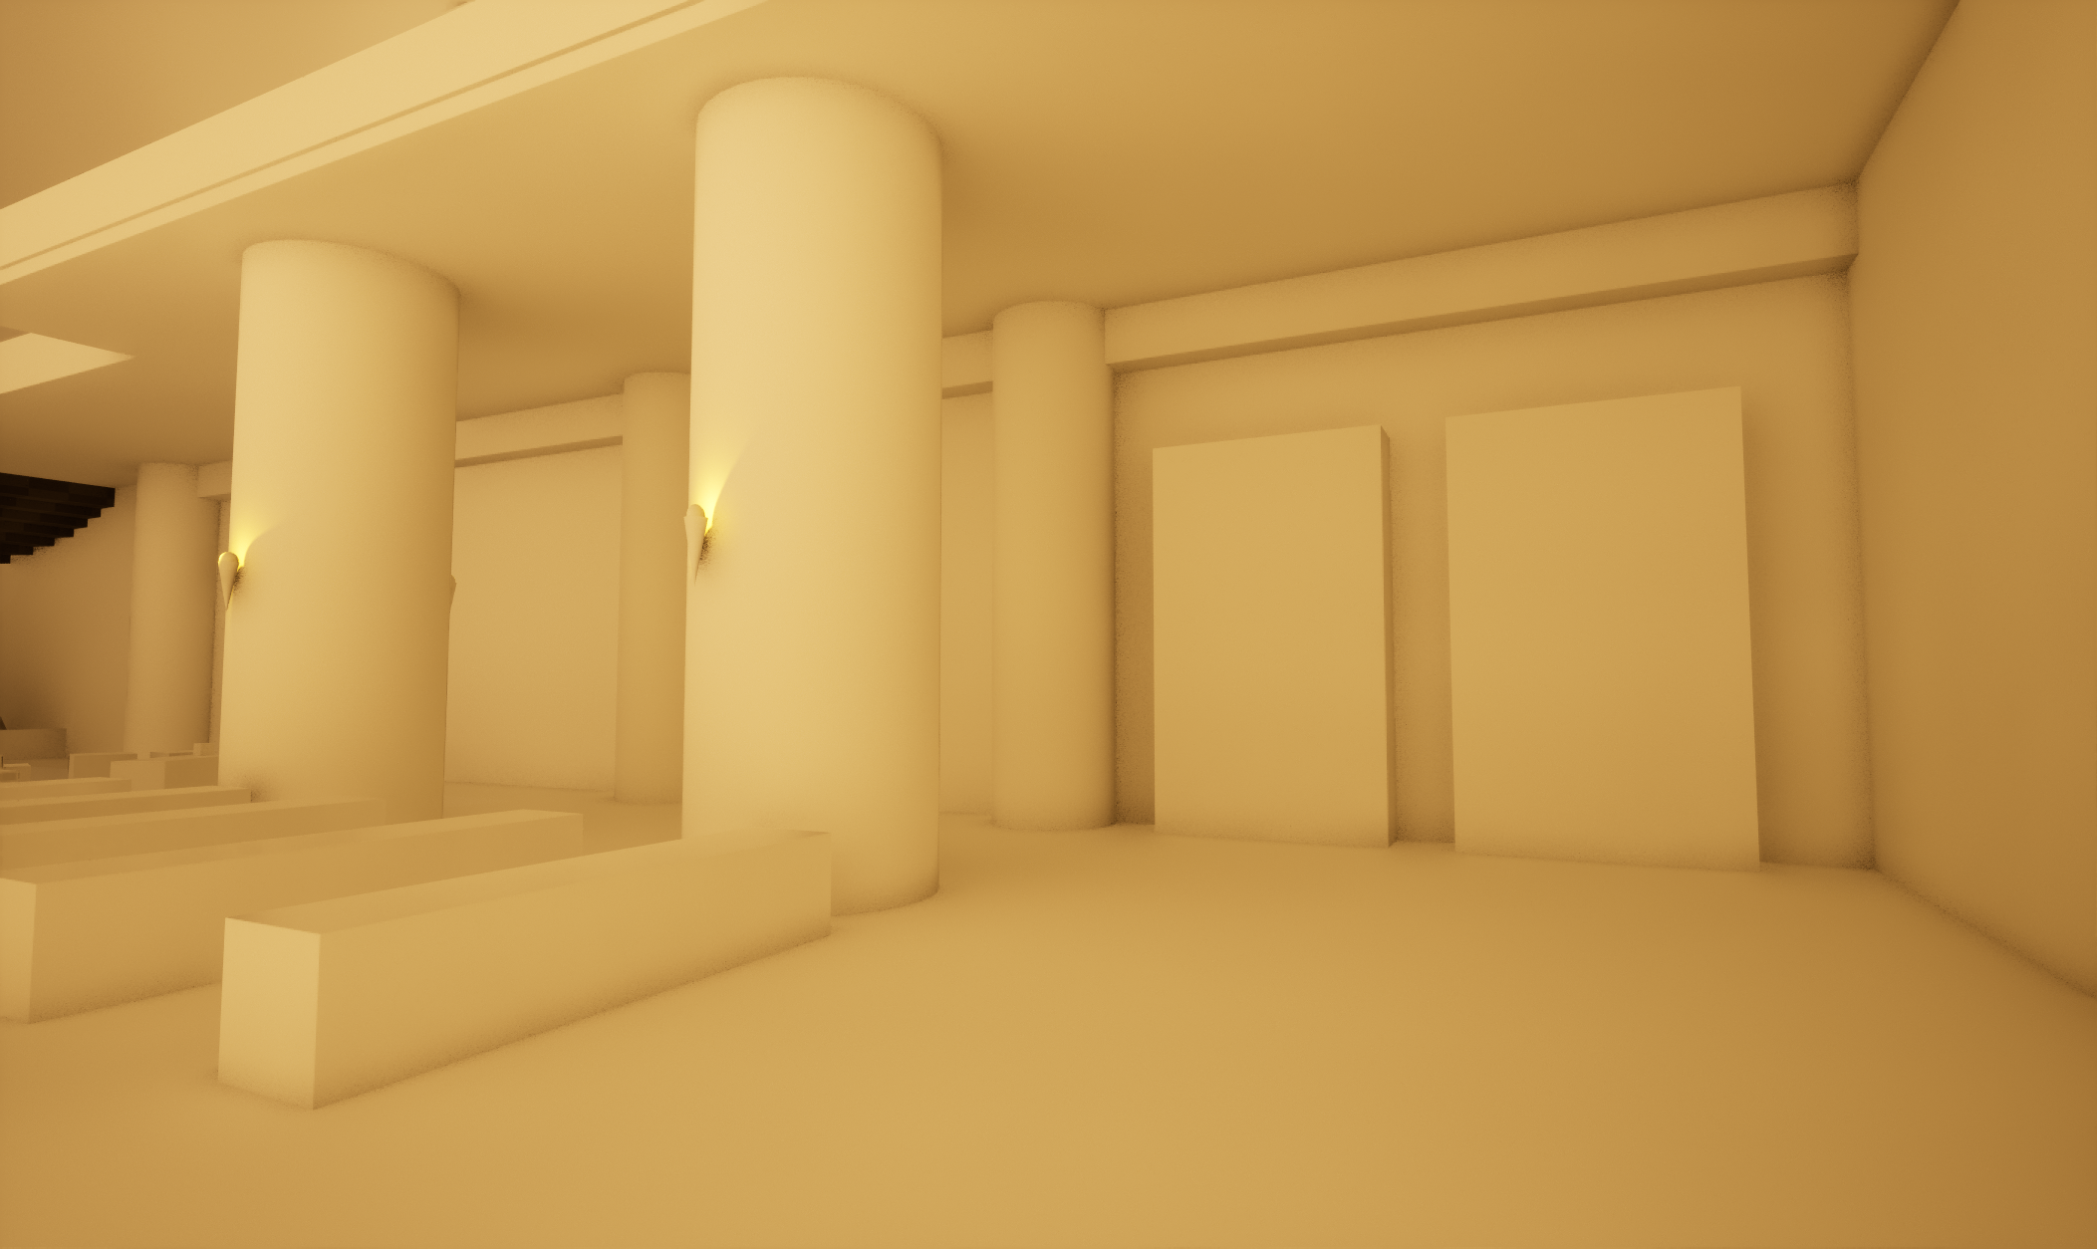

Moving deeper into the hall the player will find a stoned carved lectern underneath a large tree under the skylight. The trees roots will be present pushing through some of the floor displacing the floor and breaking up its shape. Behind the tree are some large planters full of shrubs and foliage which sit under the stairs twisting up to the two lofts.

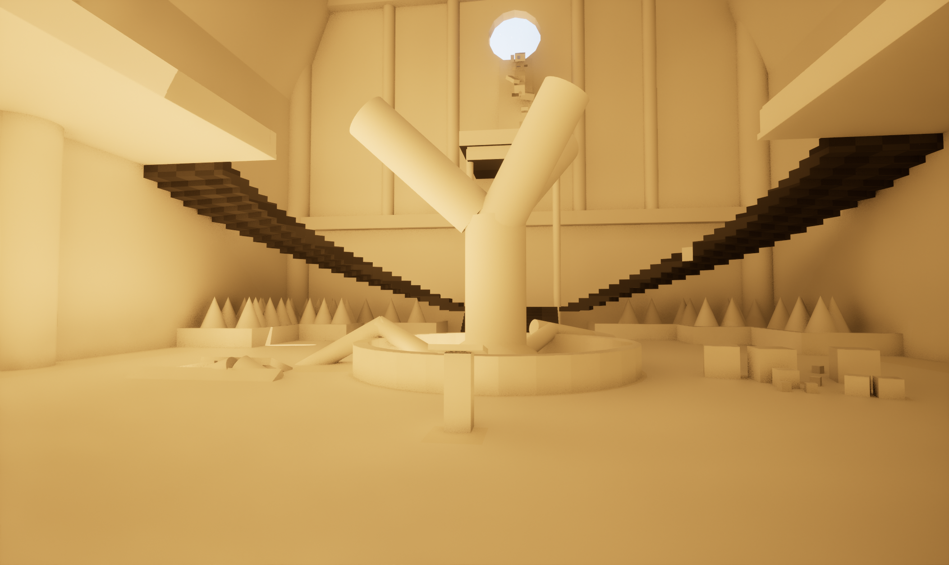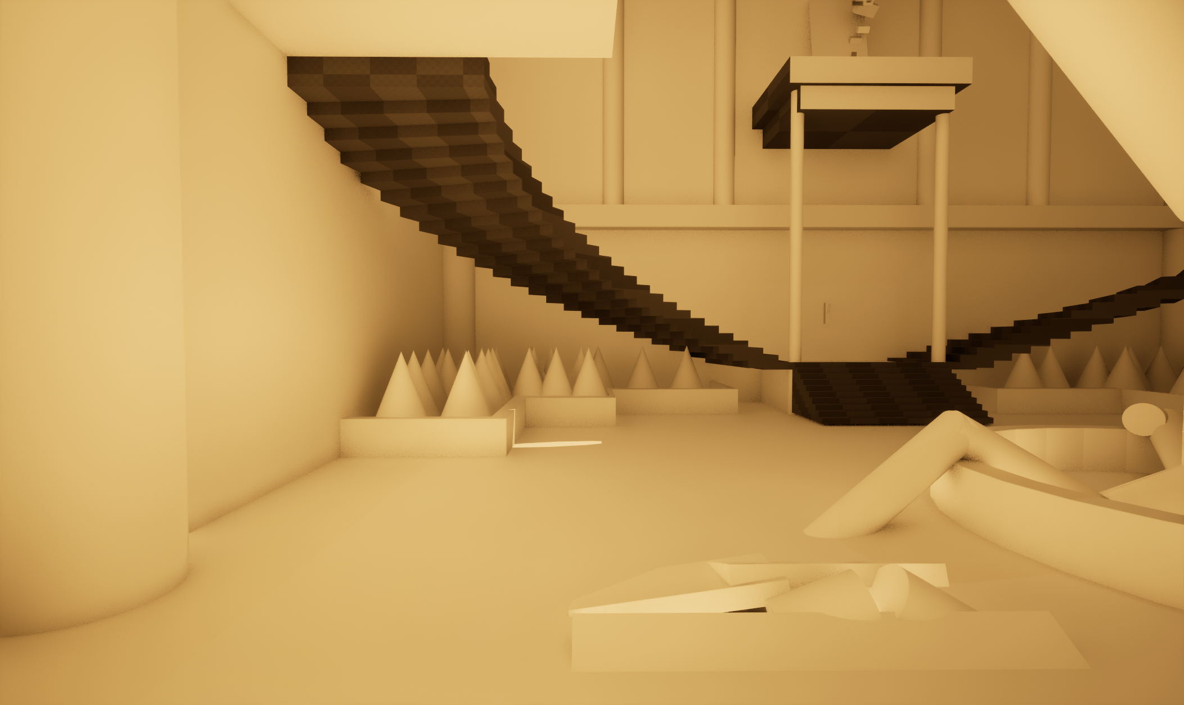

At the base of the stairs there will be a lever underneath a tall platform which when interacted with will cause water to flow out of the circular cavity in the wall and onto the platform.

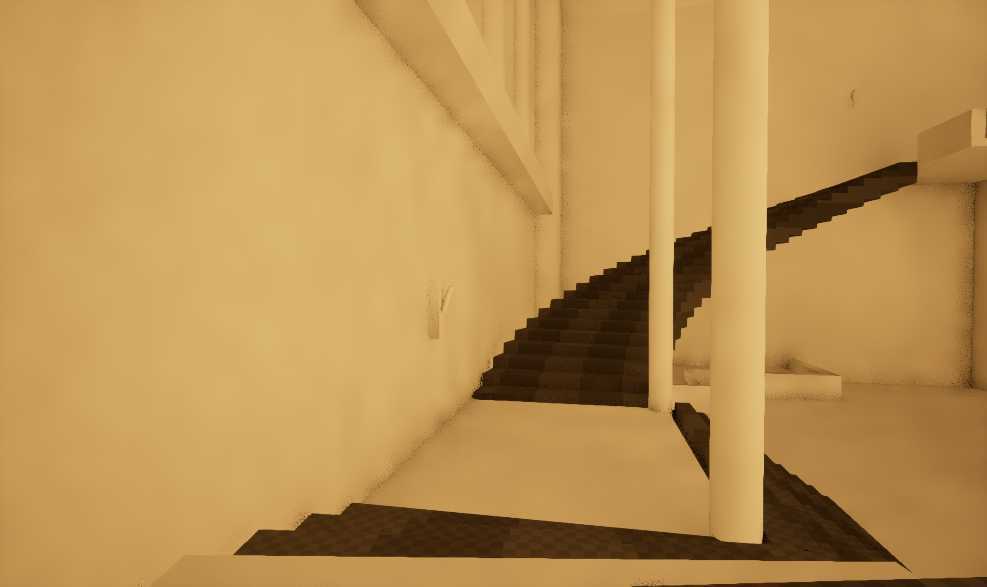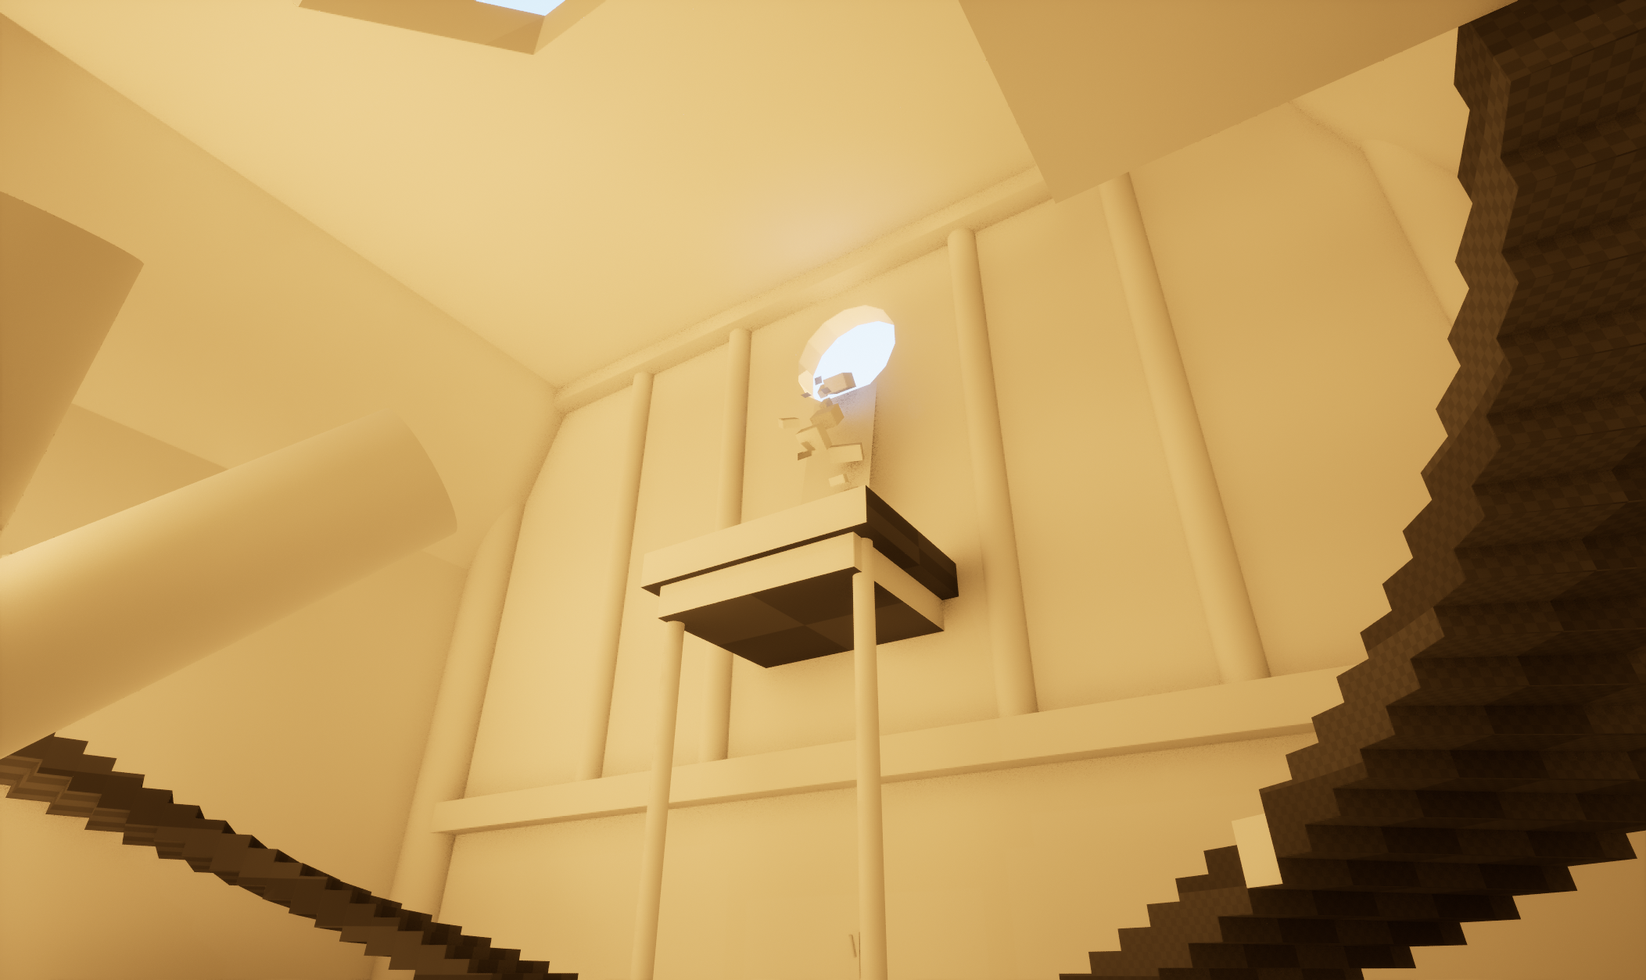

**Upper Floors**

Up either set of staircases will lead the player to some spaces which contain furniture such as desks or work stations, with debris and sculpting tools/ stone tablets lying around. There are some shelves and benches against the wall as well. On the walls are more sconces which can be interacted with to light them or snuff them out.

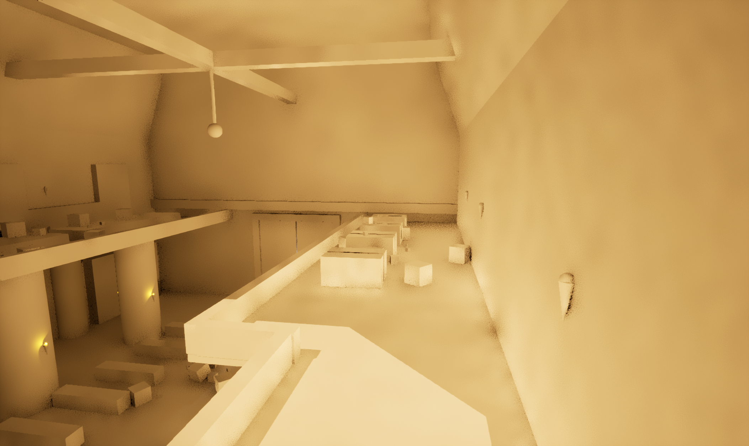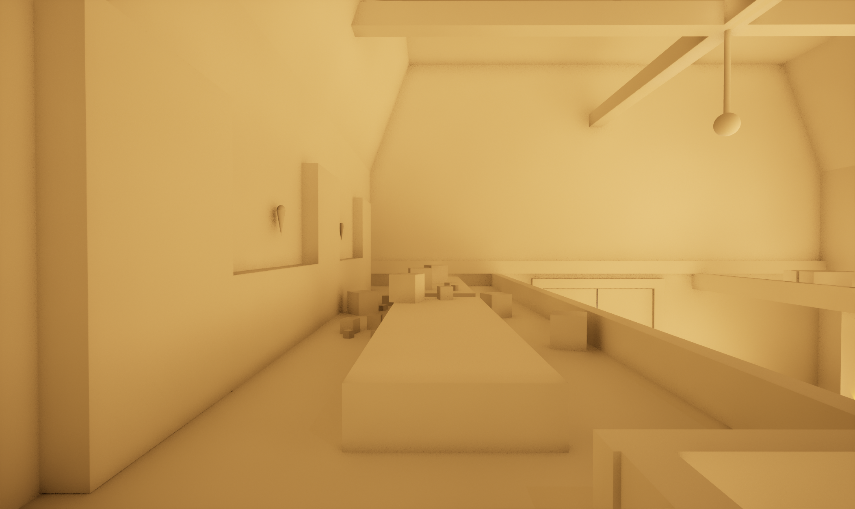

**Interactive Objects:**

**Rubble and Debris:**  Rocks and stones of varying sizes which can be picked up and moved around by the player with basic physical interaction.

**Lever:** Simple on-off switch which controls the VFX system for water to pour into the platform above.

**Wall Sconces:** Light sconces which can be turned on and off with real-time lighting being calculated and changing as they are turned on and off

**Aesthetic and Style**

The original source of inspiration for this environment was from one of my favourite games Shadow of The Colossus, specifically the towering temple hall with light being cast down from a skylight in the ceiling. I wanted to use lighting in my scene in a similar fashion drawing focus to the centre of the room.

For my materials I looked into artists scenes focusing on stone interiors one such example shown here which was a recreation of the medical room of Hogwarts in the Harry Potter movies.

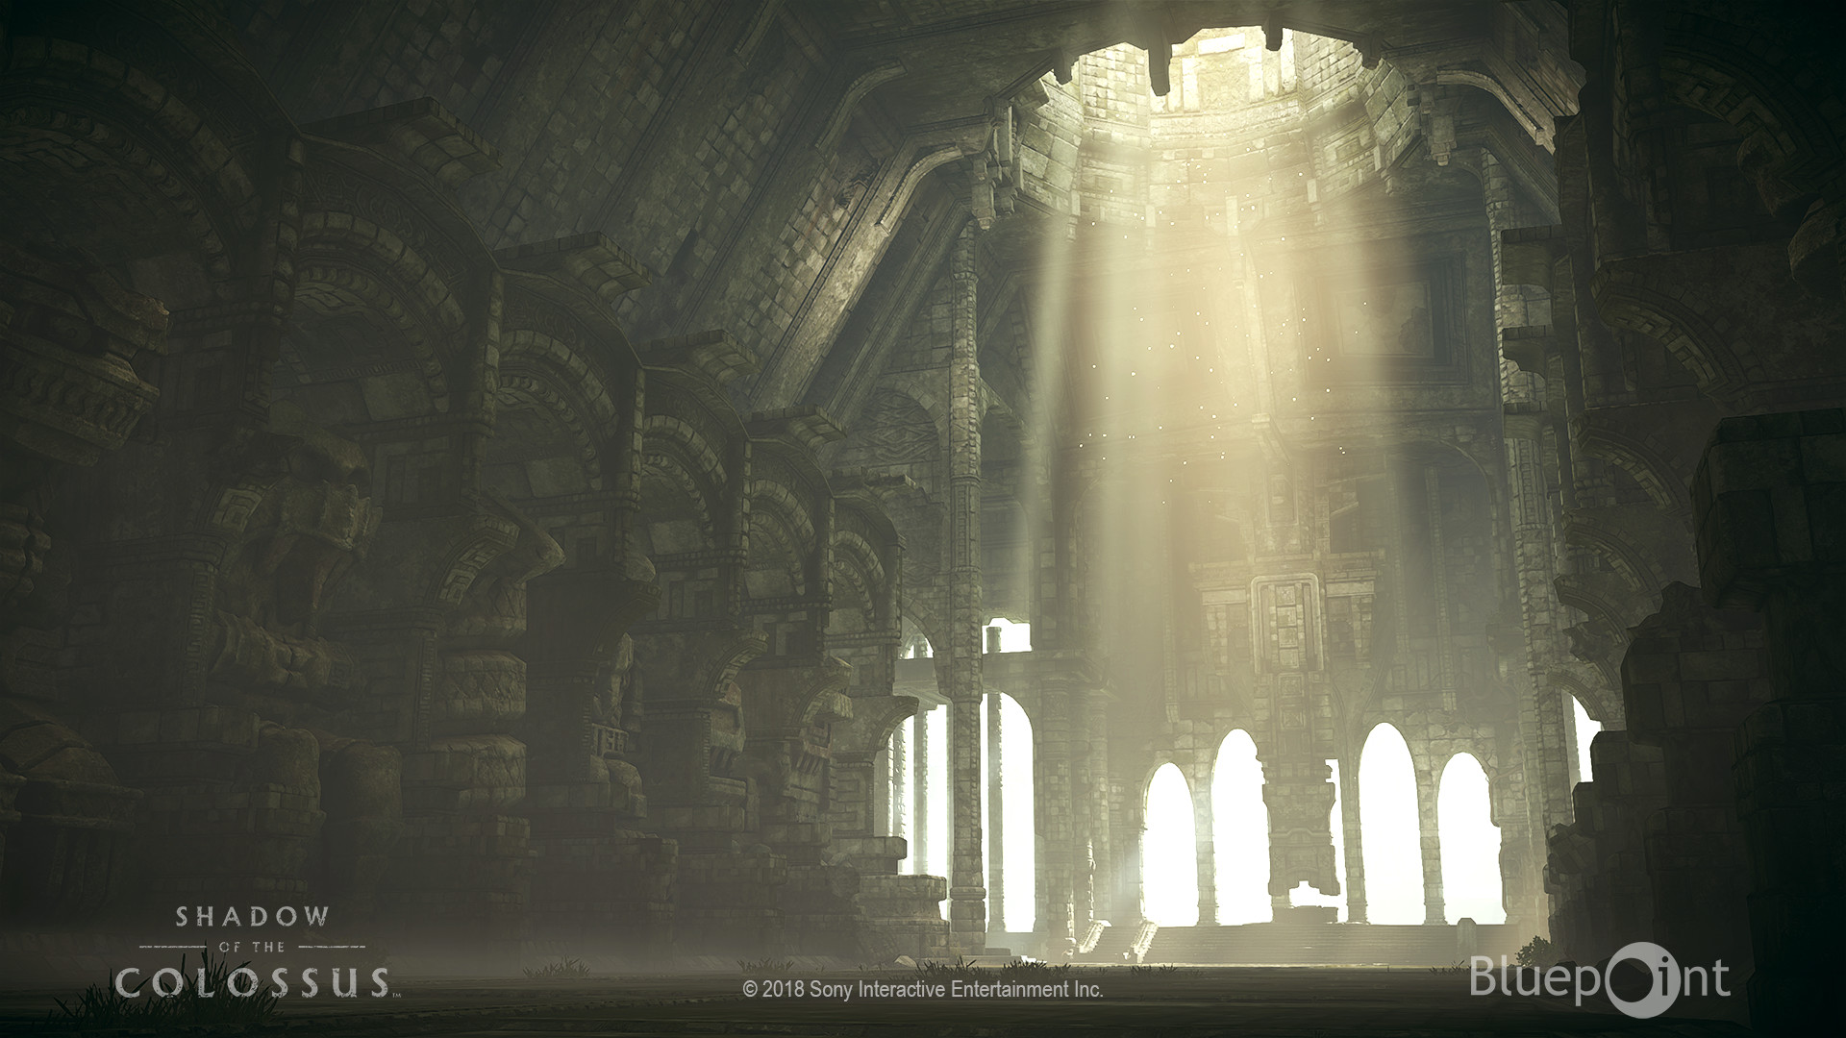Figure 1: *Shadow of the Colossus - Shrine of Worship*

*- Mak Malovic*

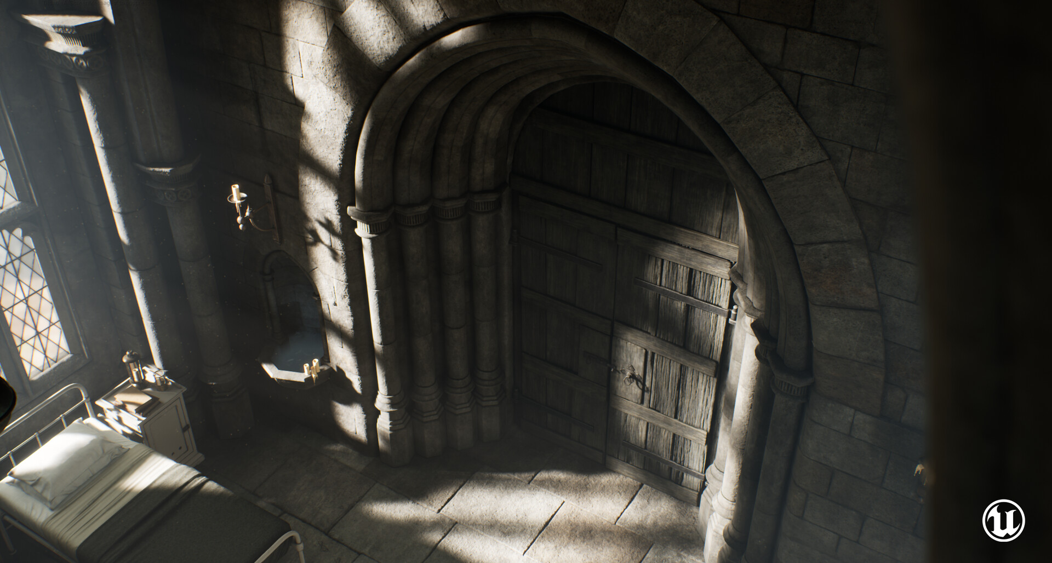Figure 2: *Hogwarts hospital - LeMar*

In regards to visual style I plan to keep a degree of realism in my materials and visual style without trying to achieve a photorealistic finish. To achieve this I plan to make materials that are less noisy and detailed with stronger saturations colour values to achieve a more fantastical and stylized appearance.

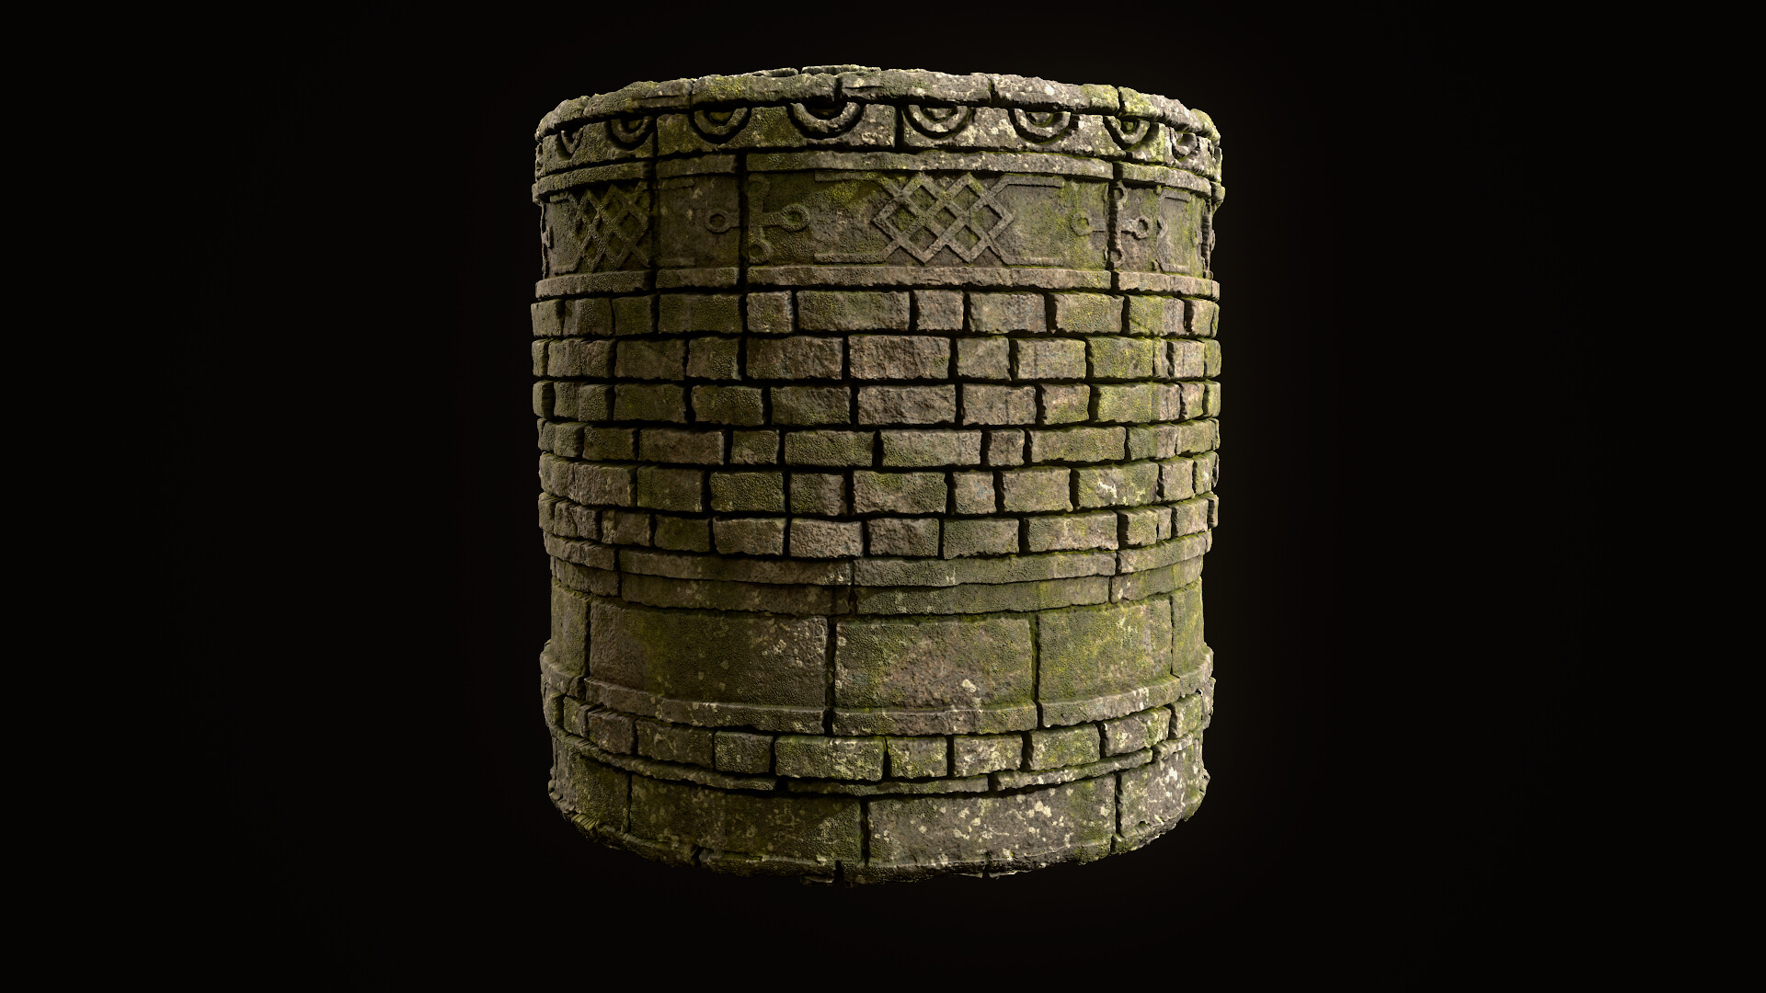Figure 3: Ancient Temple Trim Sheet – Angela Bello

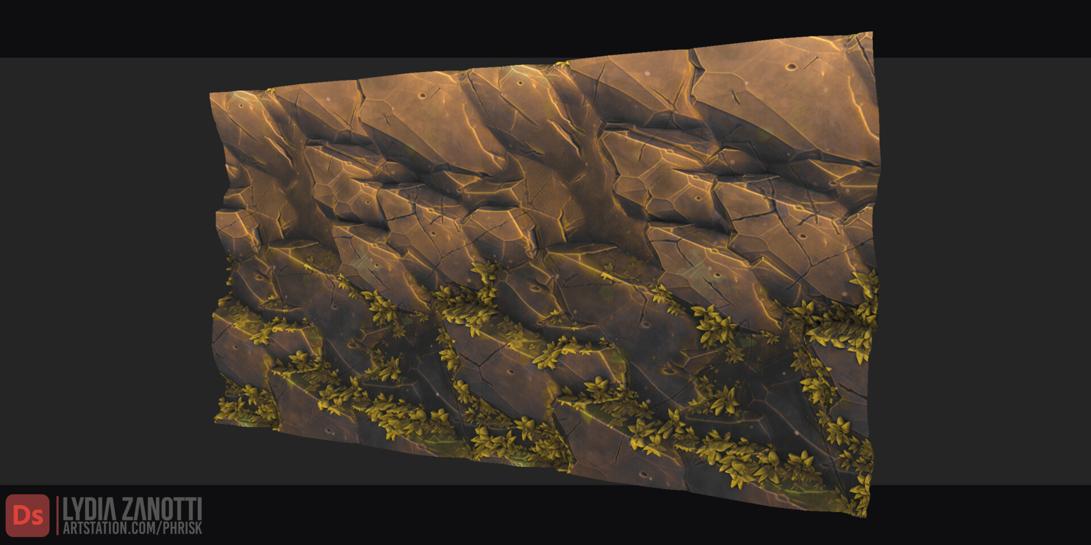Figure 4: Stylized Substance Materials – Lydia Zanotti

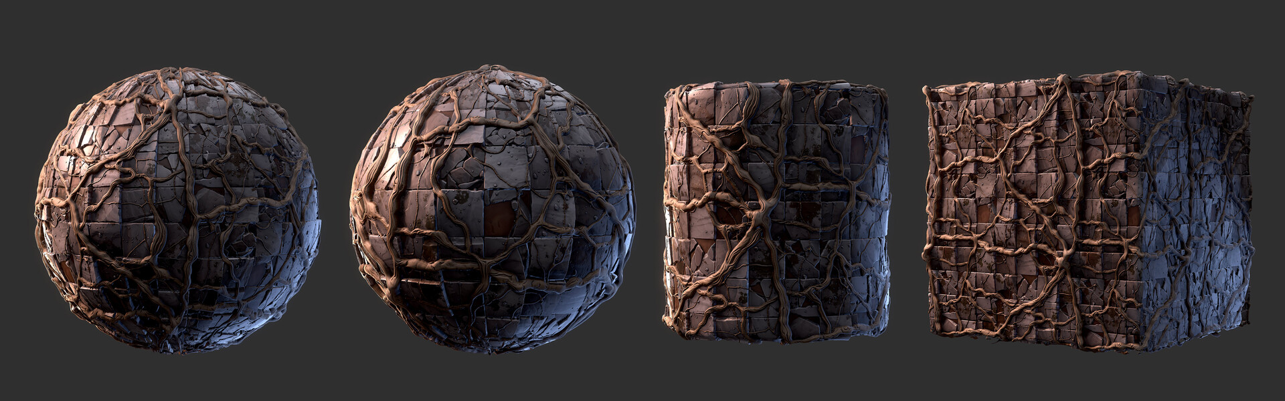Figure 5: *Stylized Old Tiles with Roots - Substance Designer - 3dExtrude*

**References**

Figure 1 : <https://www.artstation.com/artwork/meAg8>

Figure 2 : <https://www.artstation.com/artwork/Jv8D1A>

Figure 3 : https://www.artstation.com/artwork/8wO6ZQ

Figure 4 : <https://www.artstation.com/artwork/490YRk>

Figure 5 : <https://www.artstation.com/artwork/lx2vxo>